**Instructions of using PC-DMIS Go & Notification Center with PC-DMIS**

1. Installation
2. Install PC-DMIS 2019 R1 or newer version in the computer

Install file: Pcdmis2019_R1_master_14.1.2396.0_x64.exe

1. Install Notification Center in the computer

Install file: NotificationCenter_master_2.0.720.0_x64.exe

1. Install PC-DMIS Go in Android system/IOS

Android install file: com.catavolt.pcdmis_700.apk

1. Run PC-DMIS

Use PC-DMIS online or simulator to work with Notification Center and PC-DMIS Go.

1. How to use PC-DMIS simulator

Modify the **simulate.dll** in PC-DMIS install directory to **interfac.dll**

1. Start PC-DMIS simulator

Run PC-DMIS 2019 online, you can see the below window when open PC-DMIS. The simulator is working now.

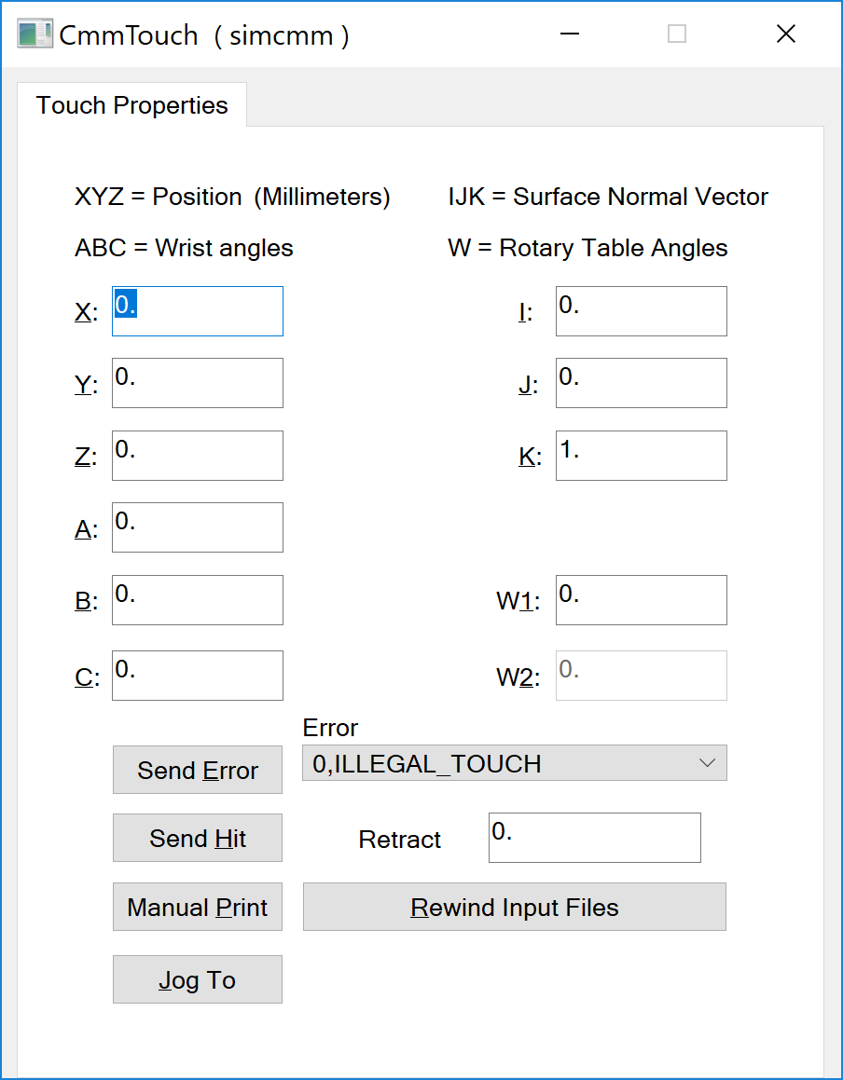

1. Run Notification Center 2.0
2. Create account

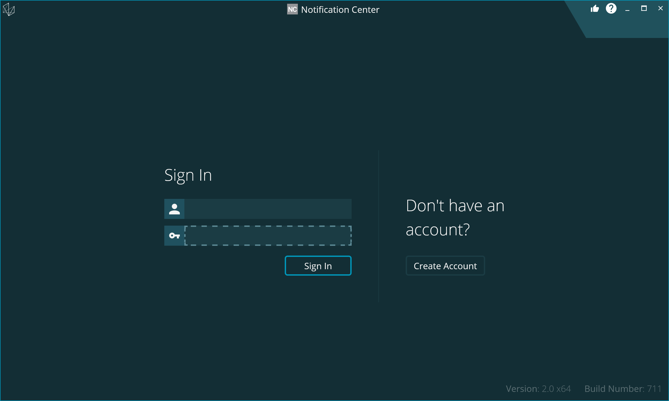

Fill the data below, If you are connected to a CMM, verify that the Serial Number is correct. If you are using the simulator, this field can stay 0000-0000.

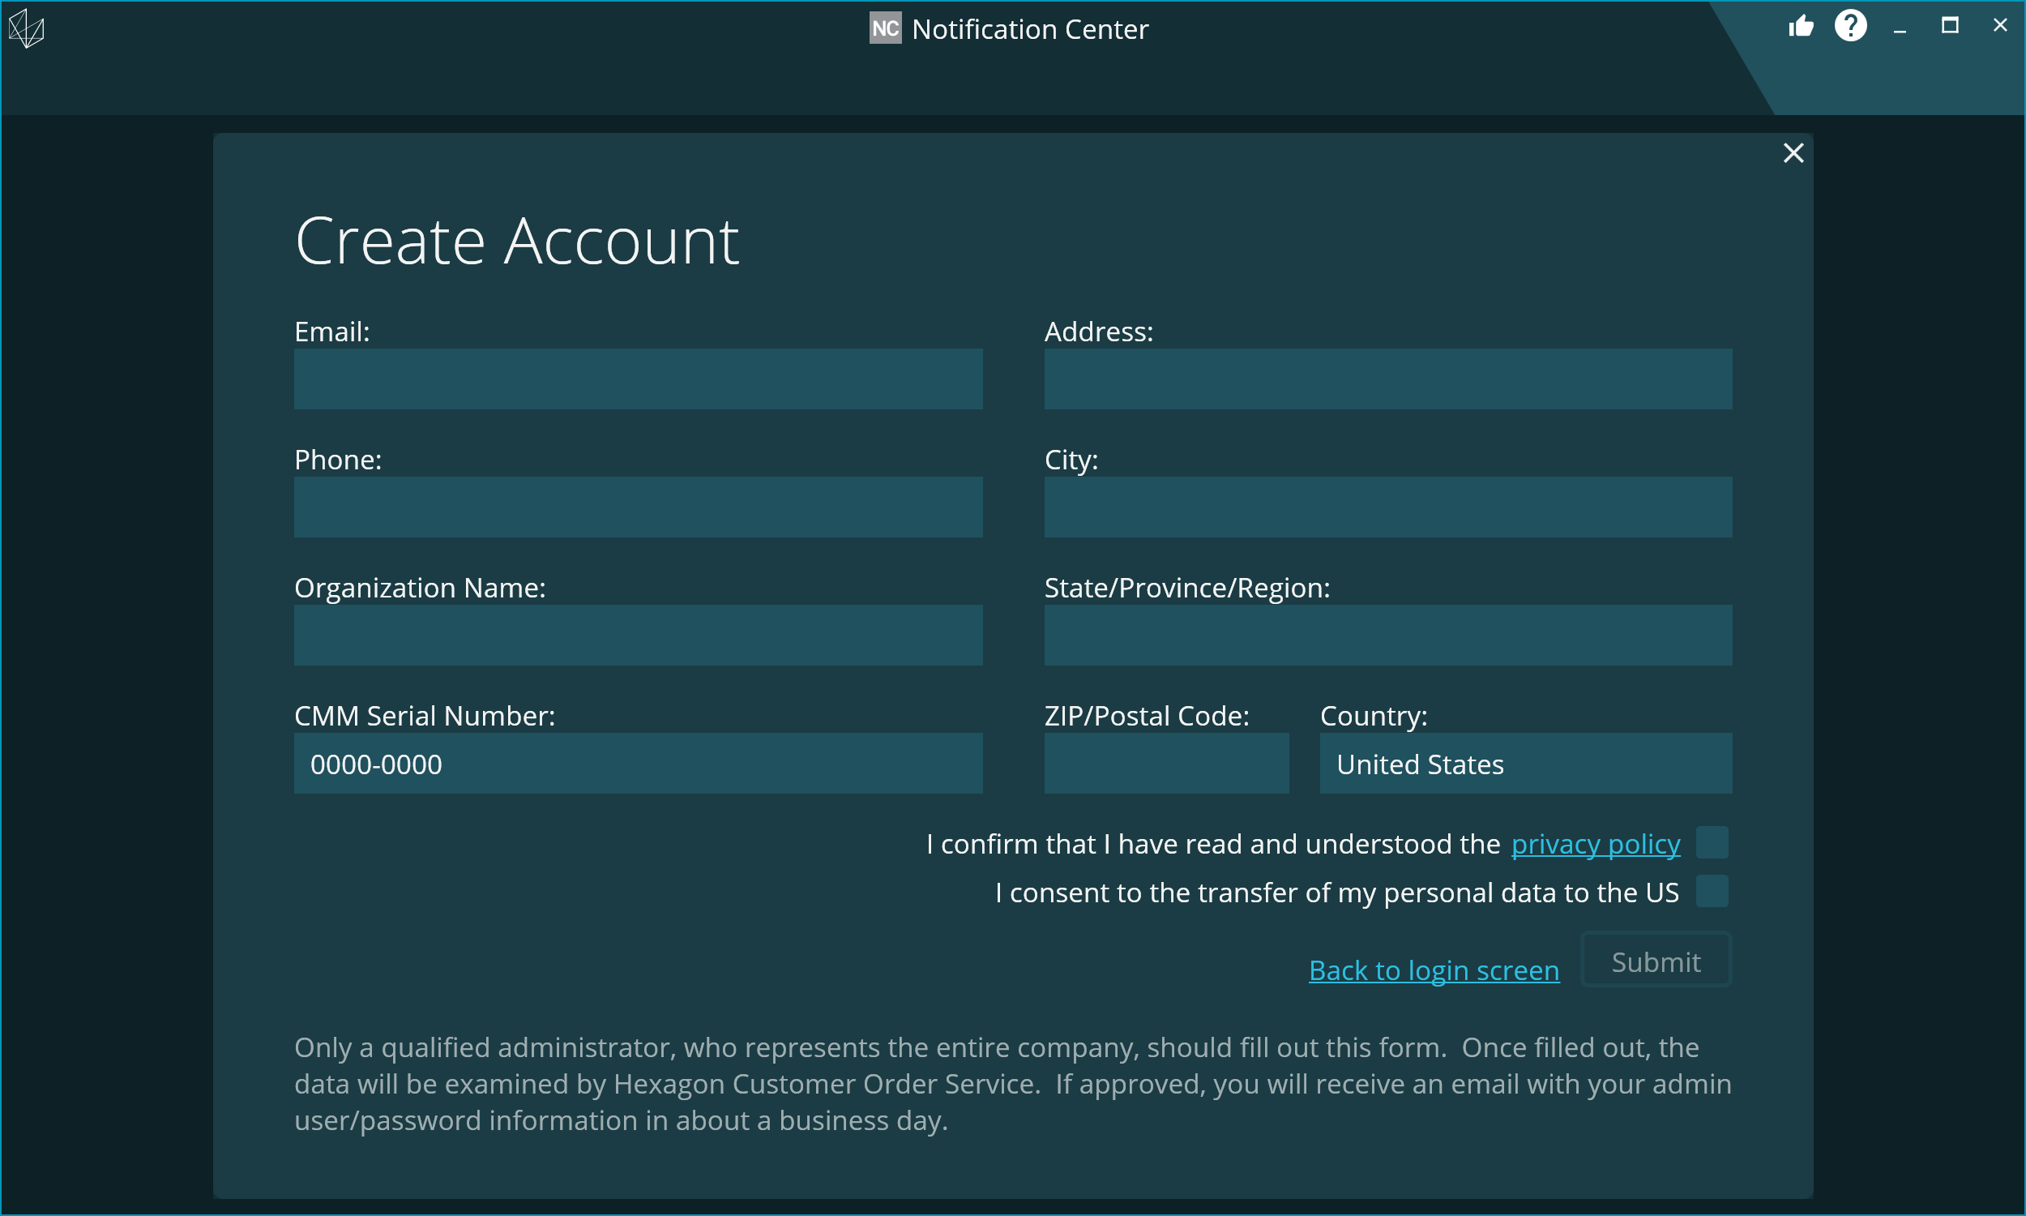

Submit the form. A response should take no more than 1 day with your log in credentials.

1. Login Notification Center

After you get account information, you can login Notification Center.

1. Verify the status

Click on the “i” button in the bottom left corner and verify that all 7 status checks are green. It may take several seconds for all to turn green.

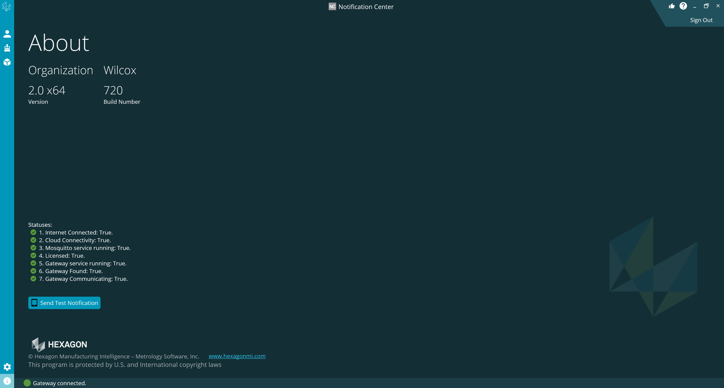

1. Machines

In NC, you will see a list of devices that have been auto discovered. The devices will be listed by date and time of when they were discovered.

The machine is detected after a routine is executed from PCDMIS online or simulator.

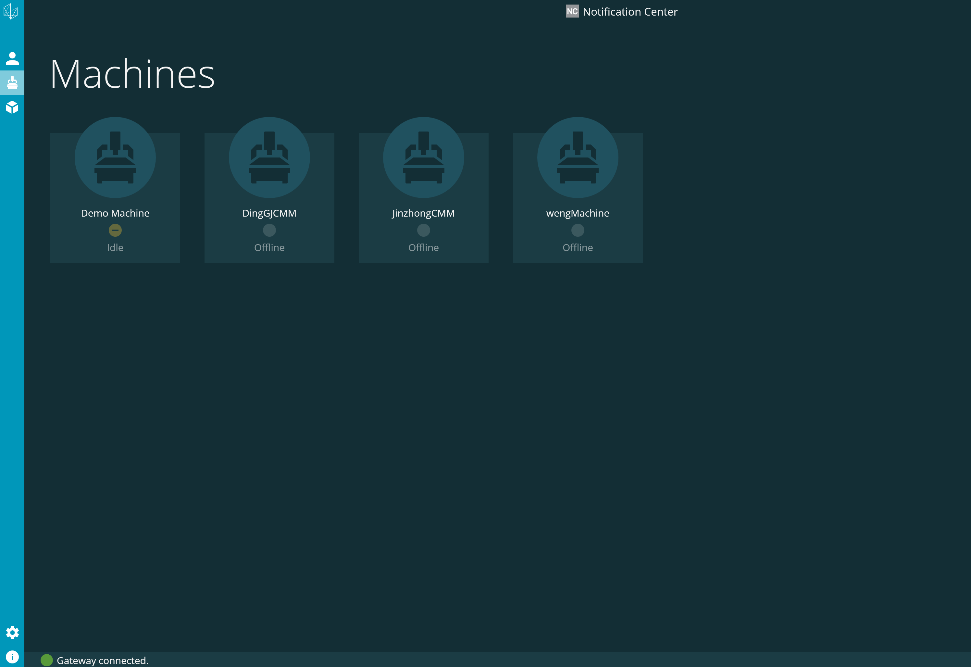

Double clicking on the device icon will also show the name found in the PC-DMIS Help | About screen for the Machine ID.

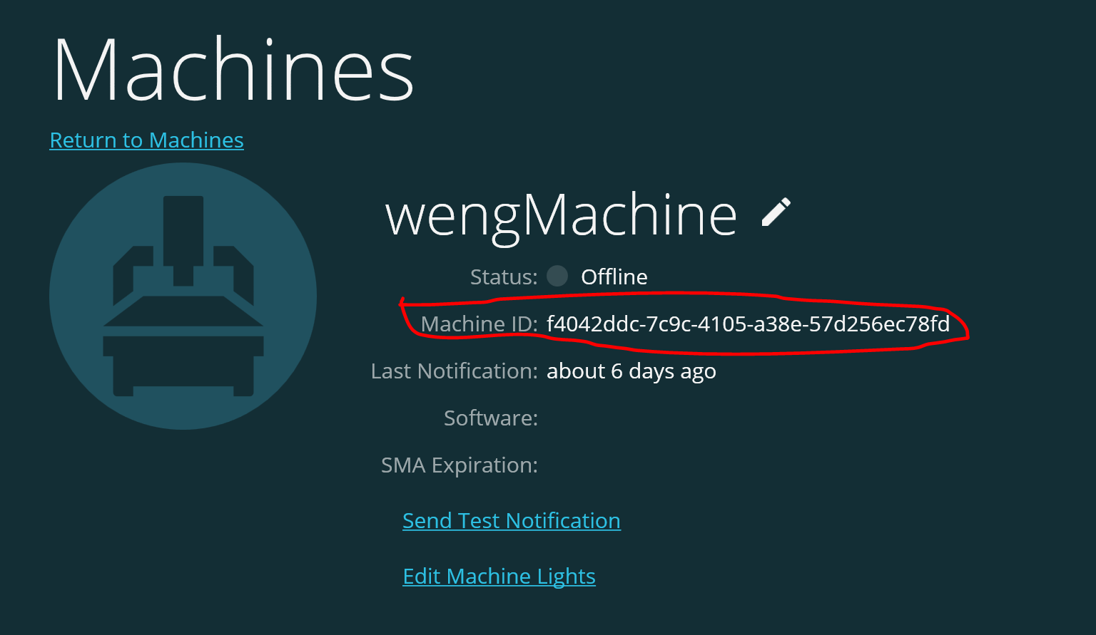

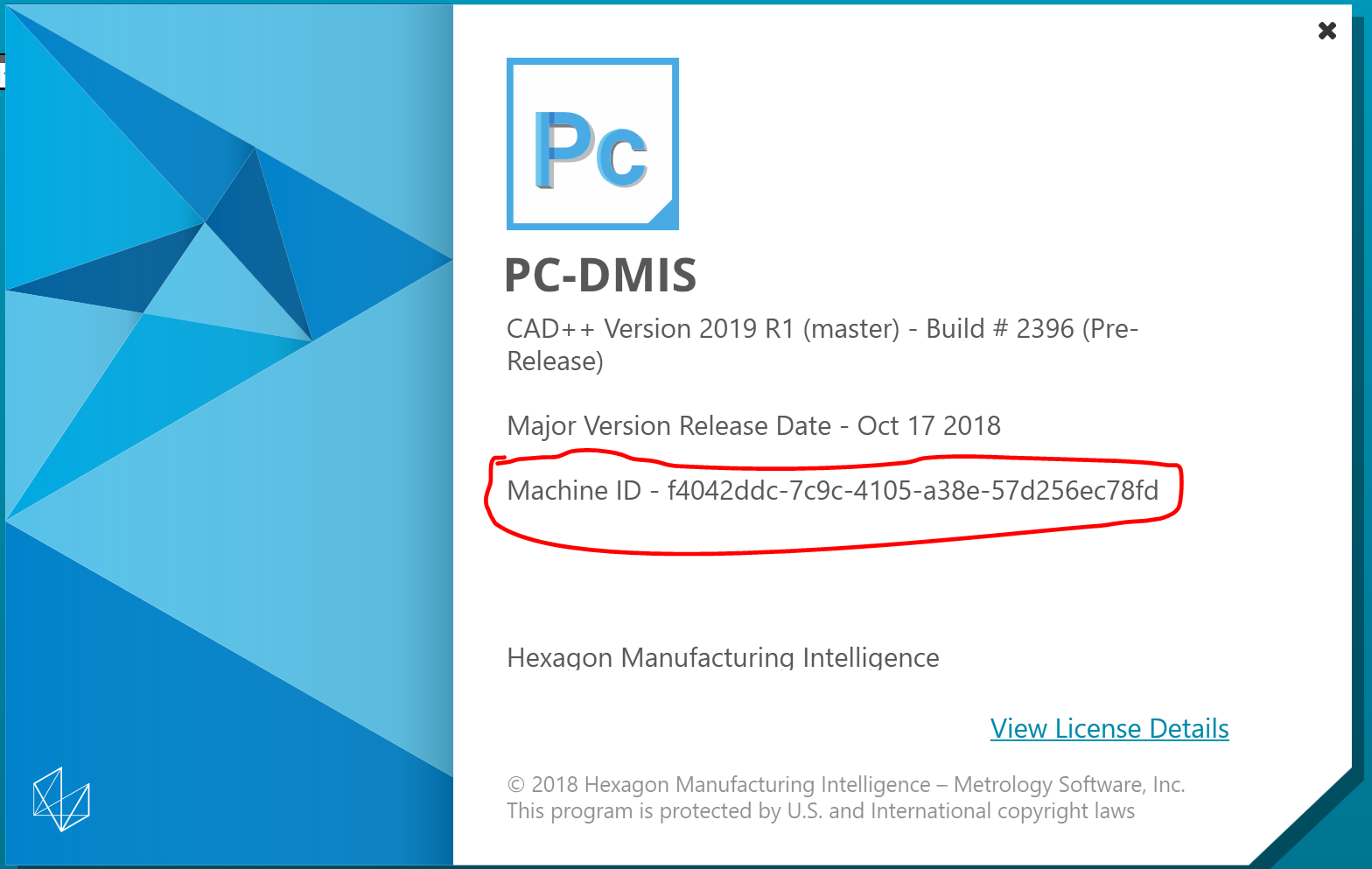

Change the name of the device by double clicking on it from the list and select the pencil icon next to the name. Select the check to save and Return to Machines when done.

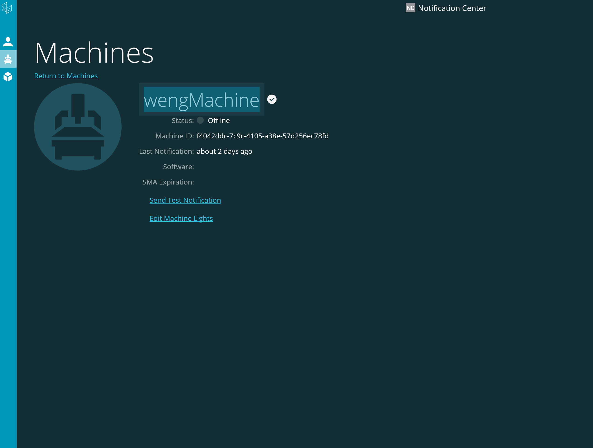

1. Routines

We can see all the routines which are executed in PC-DMIS. The routine is auto detected.

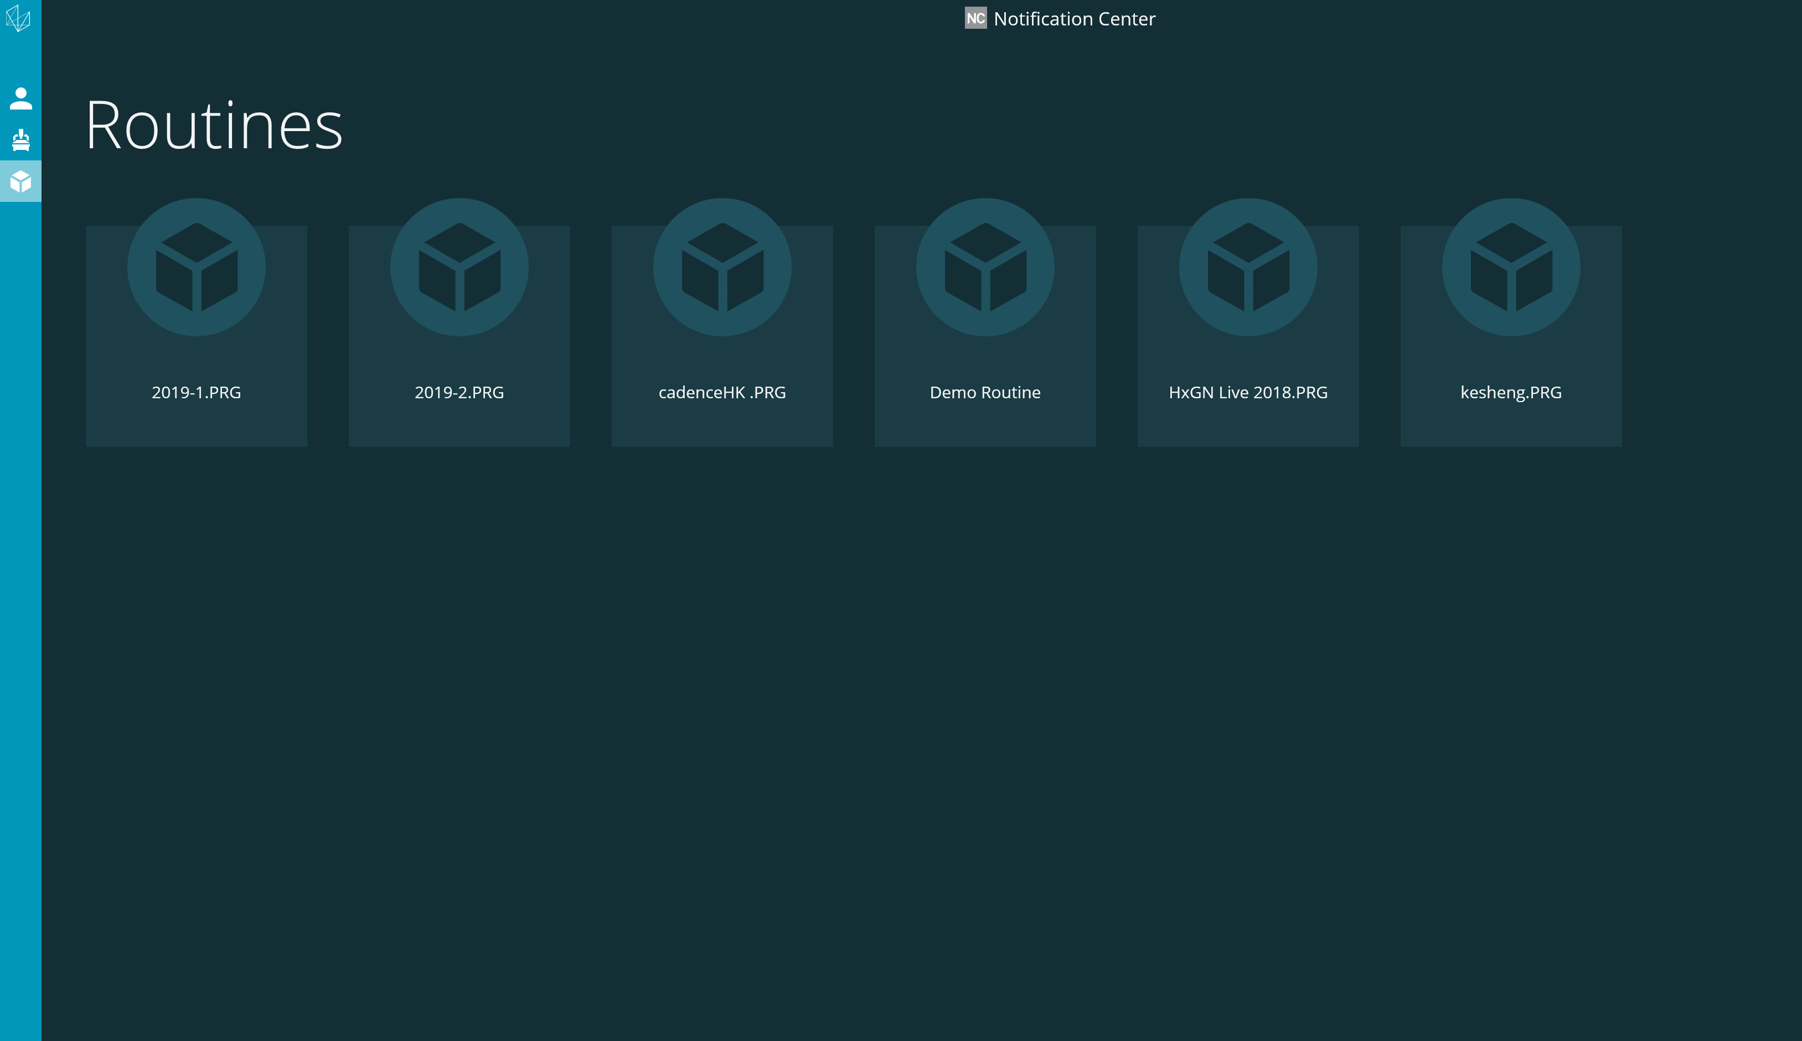

1. Run PC-DMIS Go
2. Login PC-DMIS Go use the same account as Notification Center

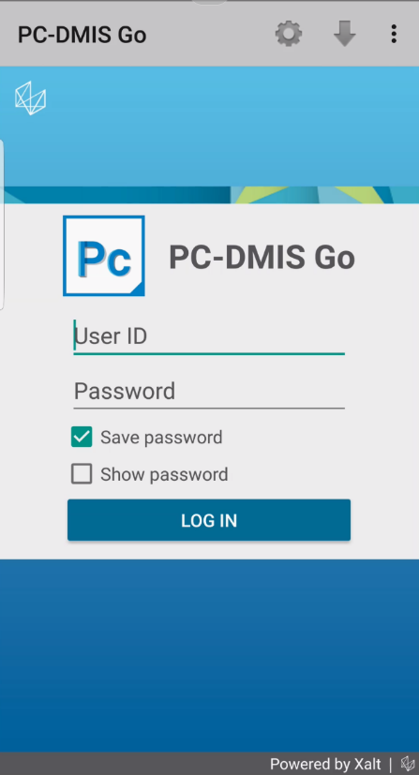

1. Configuration of PC-DMIS Go

Select Settings

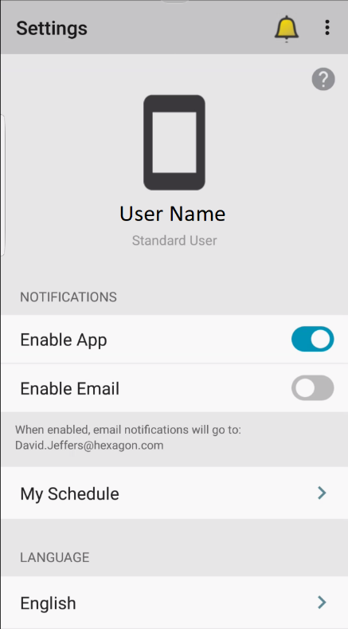

Verify that the app is enabled. Enabling E-mail will send notifications to the e-mail address you provided during registration.

Select My Schedule to identify the time and days you wish to receive notifications.

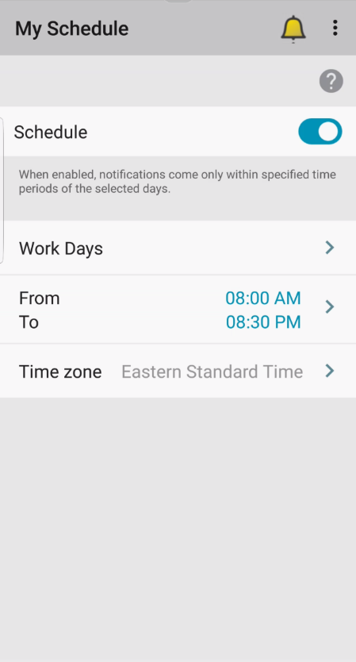

1. Add a new machine in PC-DMIS GO

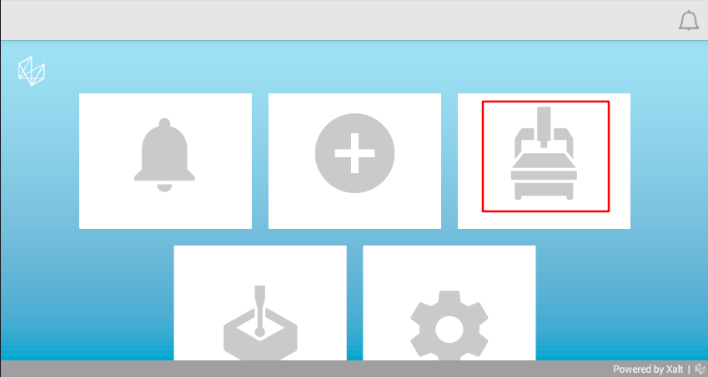

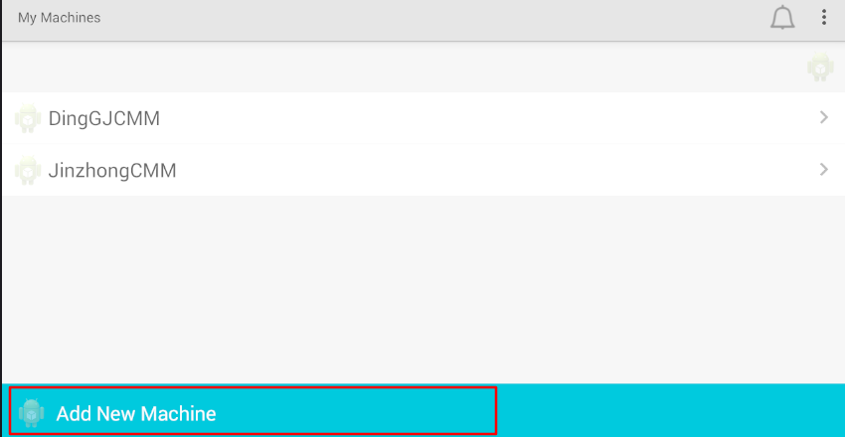

 Choose a machine from the list

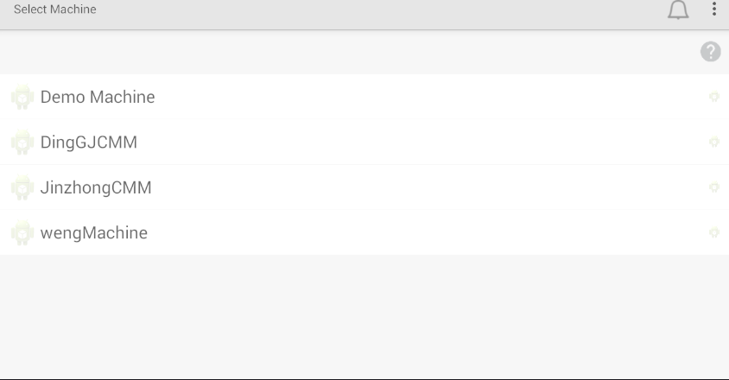

Select the notification options

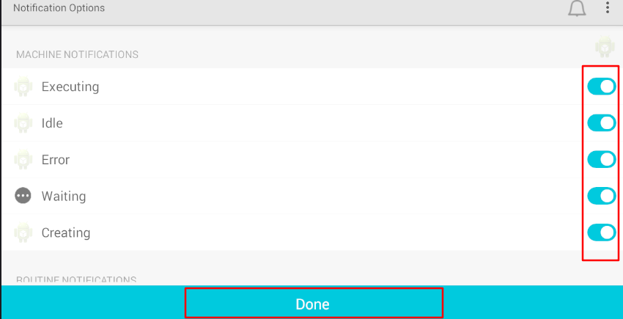

1. Add a routine in PC-DMIS GO

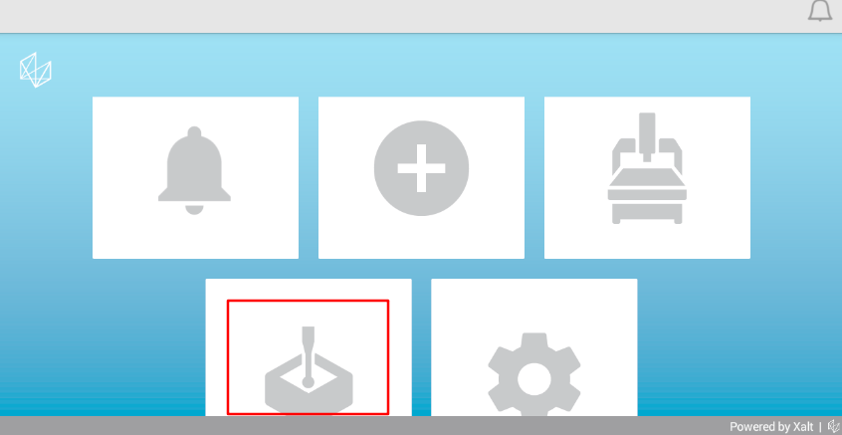

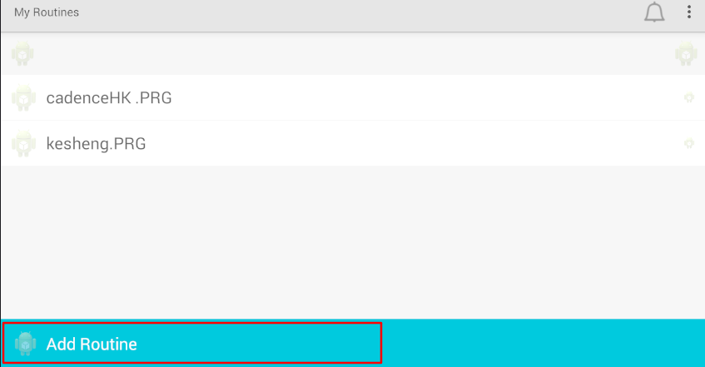

Choose a routine from list

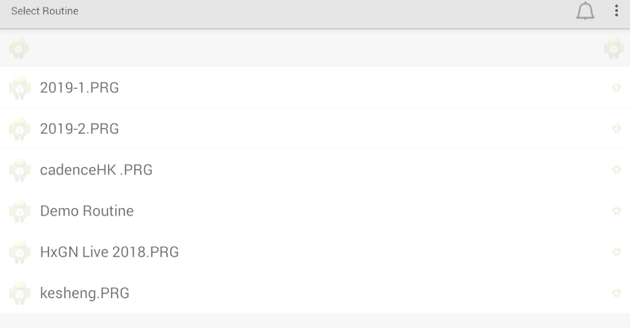

Select notification options

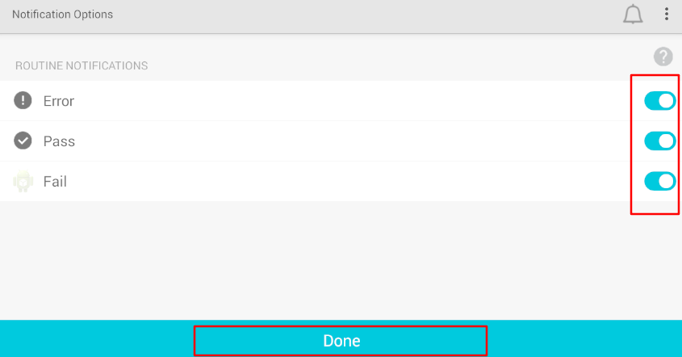

1. Execute a routine in PC-DMIS

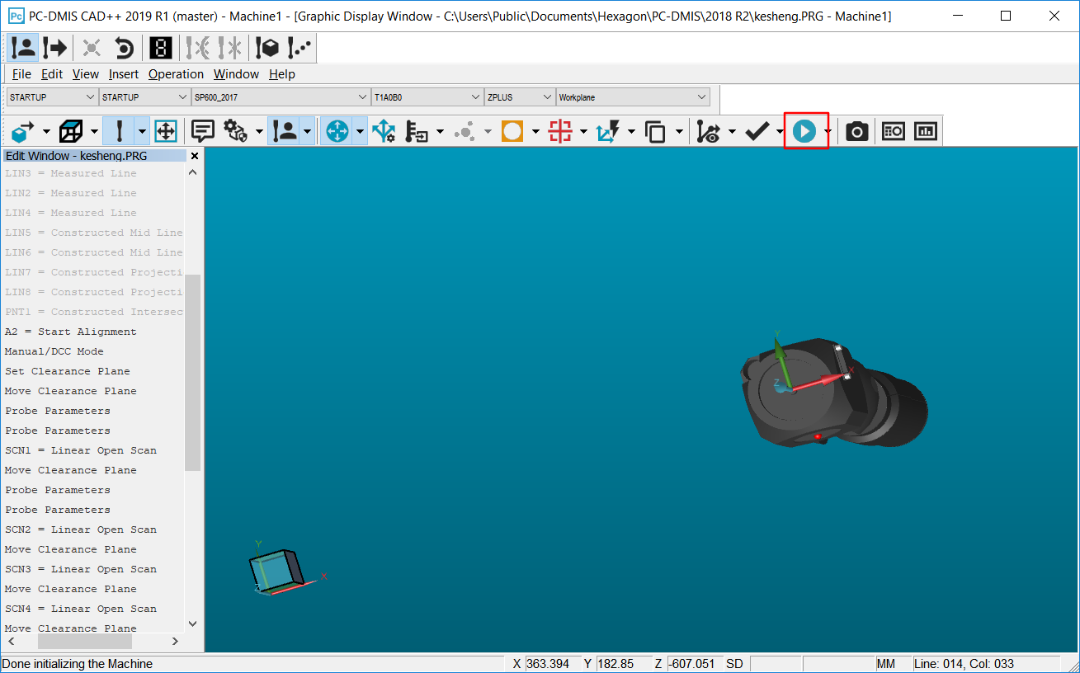

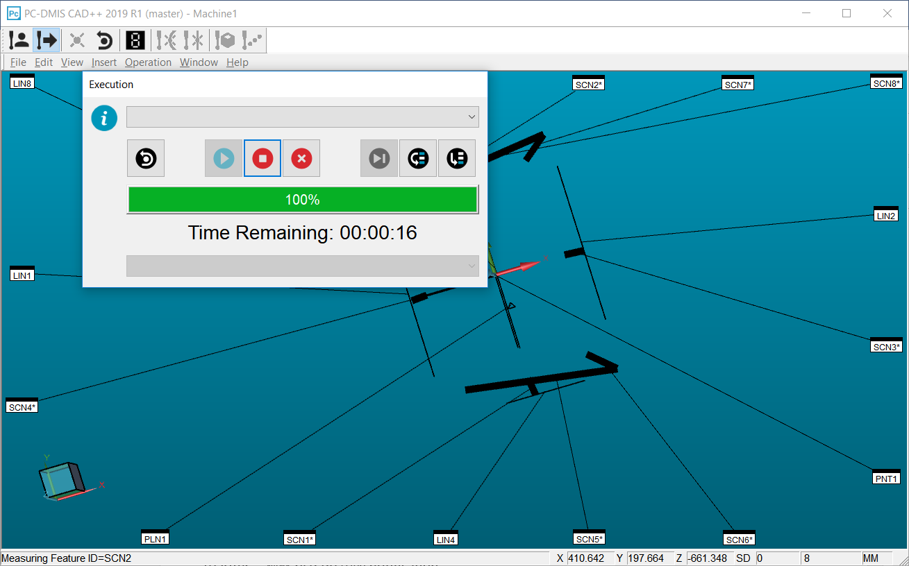

1. When the execution is finished, check the notification in PC-DMIS Go.

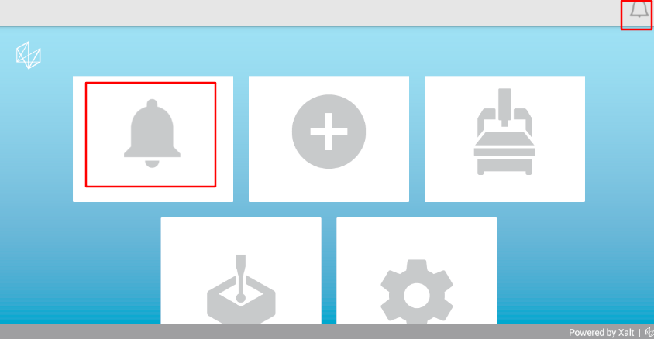

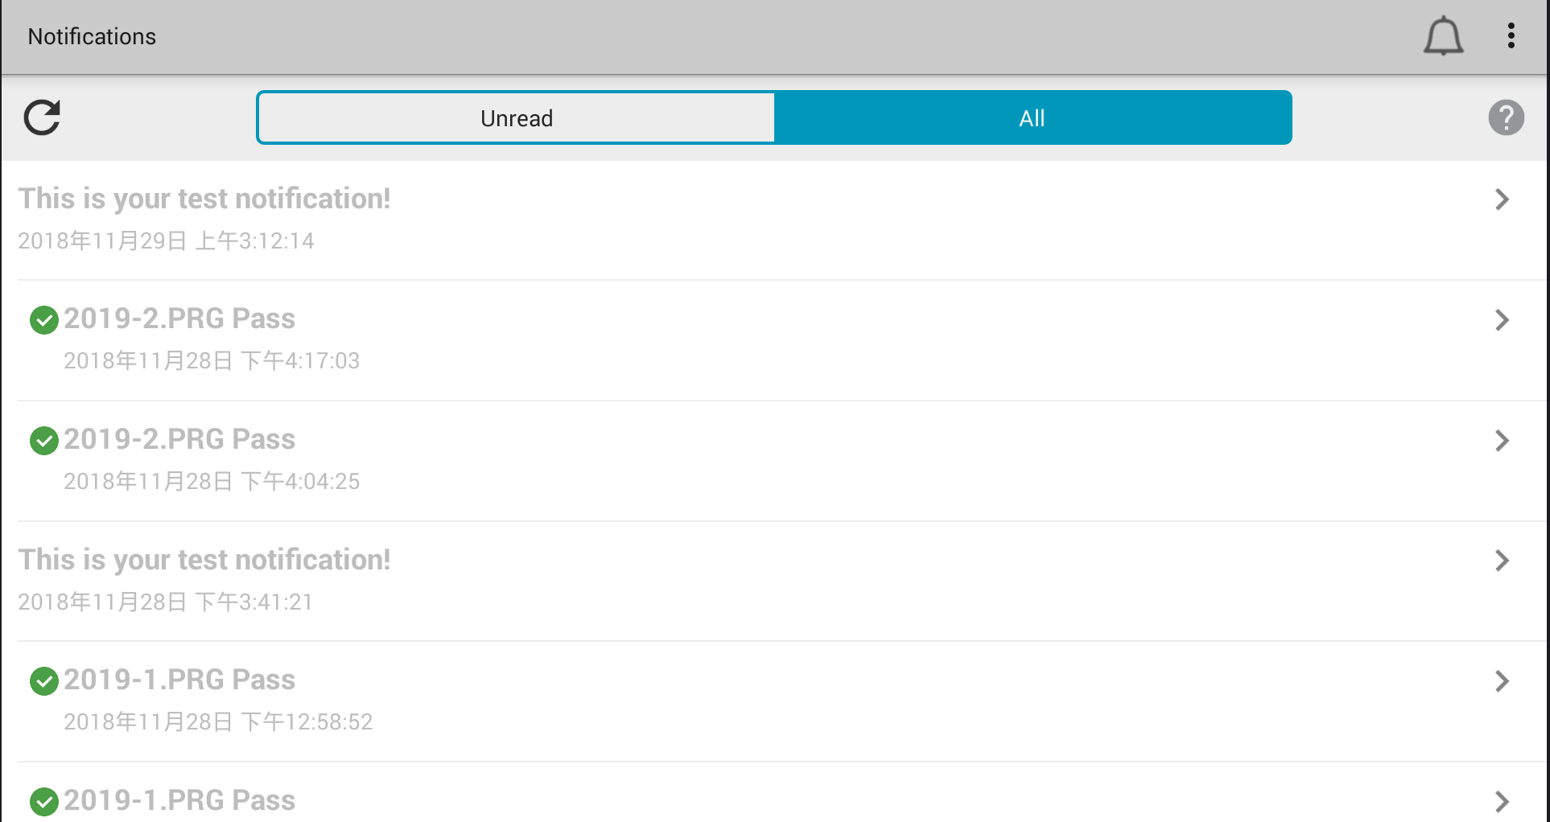

Click the open menu we can see the notification detail.

